Question no 1
Convert the decimal number (25)₁₀ into its binary, octal, and hexadecimal equivalents.
- Binary Conversion Step: Divide 25 by 2 repeatedly (25/2 = 12 R1; 12/2 = 6 R0; 6/2 = 3 R0; 3/2 = 1 R1; 1/2 = 0 R1) and read remainders from bottom to top to get 11001₂.
- Octal Conversion Step: Divide 25 by 8 (25/8 = 3 R1) and read remainders to get 31₈.
- Hexadecimal Conversion Step: Divide 25 by 16 (25/16 = 1 R9) to obtain 19₁₆.
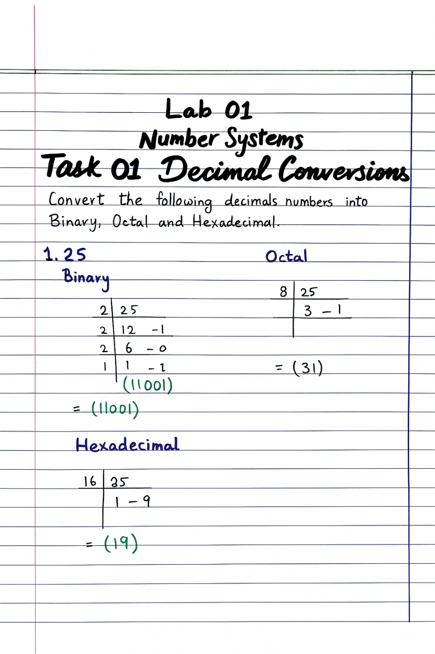
Figure 2: Manual Division for Decimal 25

Question no 2
Convert the decimal number (73)₁₀ into binary, octal, and hexadecimal formats.
- Binary Conversion Step: Perform repeated division by 2 to determine the bit pattern (1001001)₂.
- Octal Conversion Step: Divide 73 by 8 (73/8 = 9 R1; 9/8 = 1 R1) to get 111₈.
- Hexadecimal Conversion Step: Divide 73 by 16 (73/16 = 4 R9) to get 49₁₆.
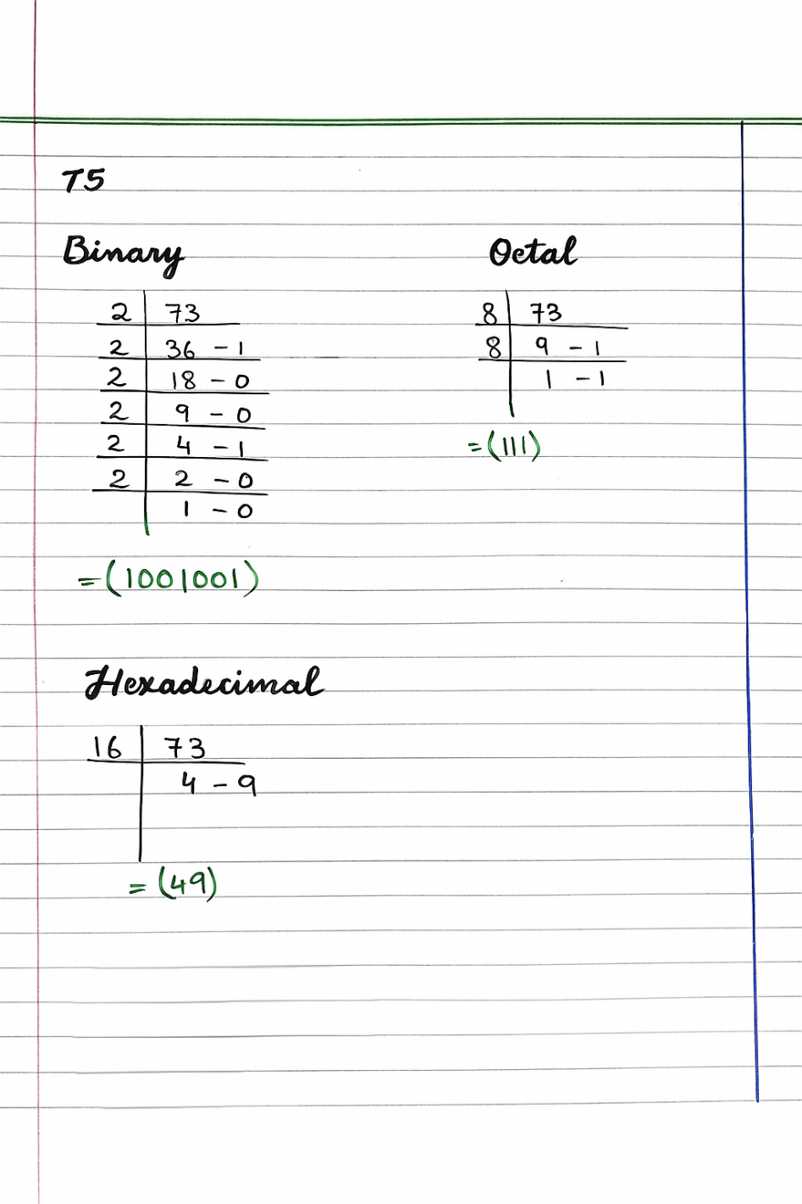
Figure 3: Number Base Breakdown for Decimal 73

Question no 3
Convert the decimal number (255)₁₀ into binary, octal, and hexadecimal.
- Binary Conversion Step: Divide 255 by 2 repeatedly until the quotient is zero, resulting in eight consecutive "1" bits: (11111111)₂.
- Octal Conversion Step: Divide 255 by 8 (255/8 = 31 R7; 31/8 = 3 R7) to get 377₈.
- Hexadecimal Conversion Step: Divide 255 by 16 (255/16 = 15 R15), converting 15 to "F" to get FF₁₆.
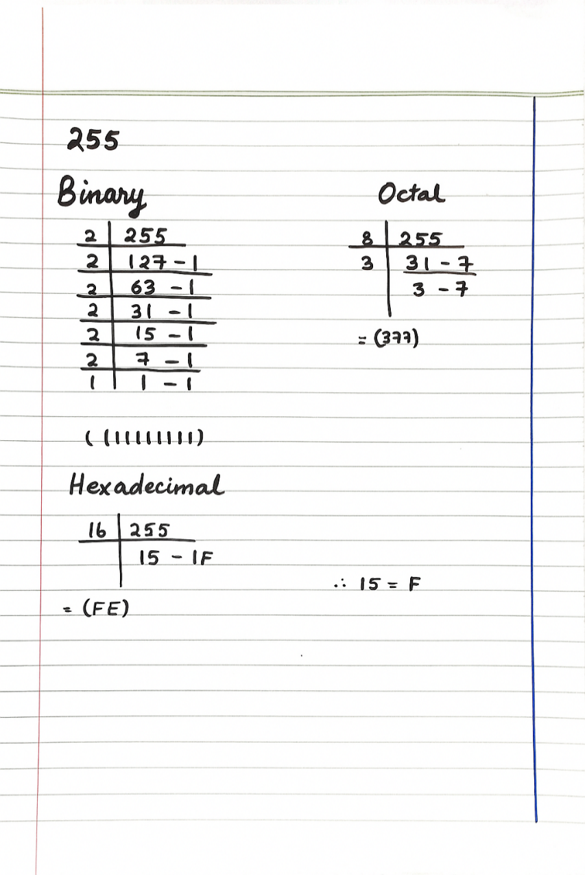
Figure 4: Maximum 8-bit Value Conversion (255)

Question no 4
Convert the hexadecimal value (2F)₁₆ into its binary and decimal equivalents.
- Binary Conversion Step: Convert the '2' to 0010 and the 'F' to 1111, then combine them to get 00101111₂.
- Decimal Conversion Step: Multiply 2 by 16¹ and 15 by 16⁰, then sum them (32 + 15) to get 47₁₀.
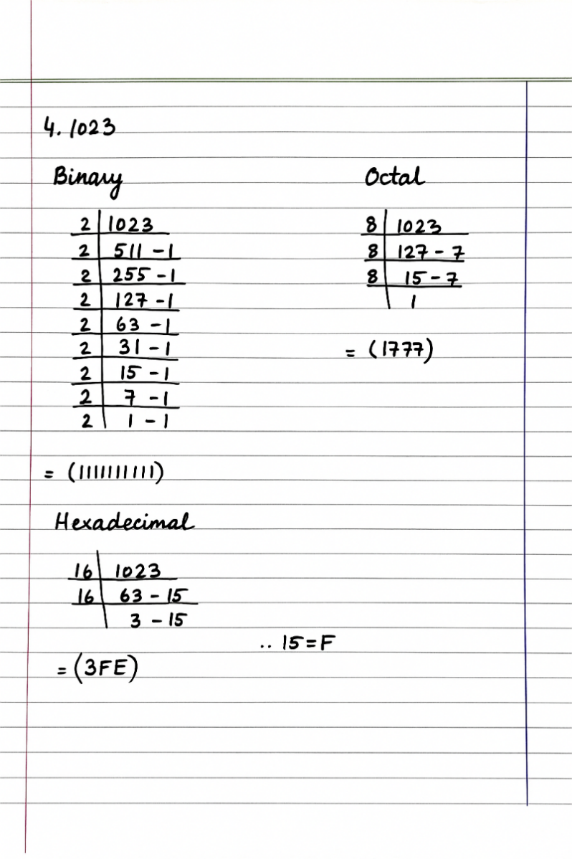
Figure 5: Hexadecimal 2F Weighted Sum calculation

Section 2: Binary Conversions
This section follows the Decimal to Other Bases tasks and focuses on converting base-2 values into human-readable and machine-efficient formats.

Binary to Decimal Conversion

Question no 1
101101

Procedural Steps
- Identify the positional weight of each bit, starting from 2^0 for the Least Significant Bit (LSB) on the right.
- Multiply each binary digit (0 or 1) by its corresponding power of 2.
- Sum all the resulting products to find the final decimal value.
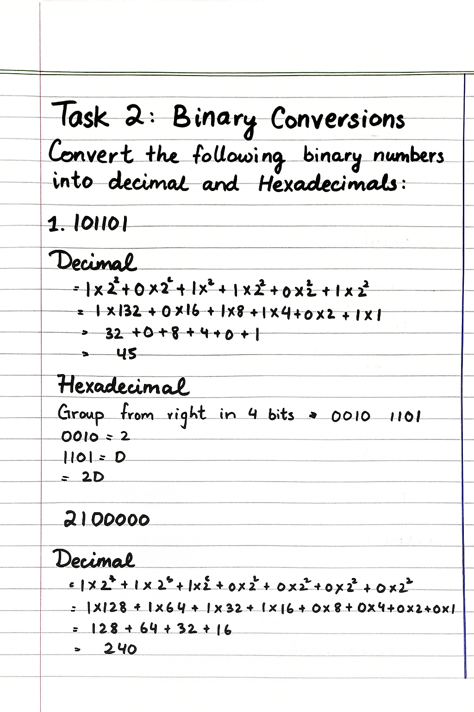
Figure 6: Positional Weight Calculation for Binary 101101

Question no 2:
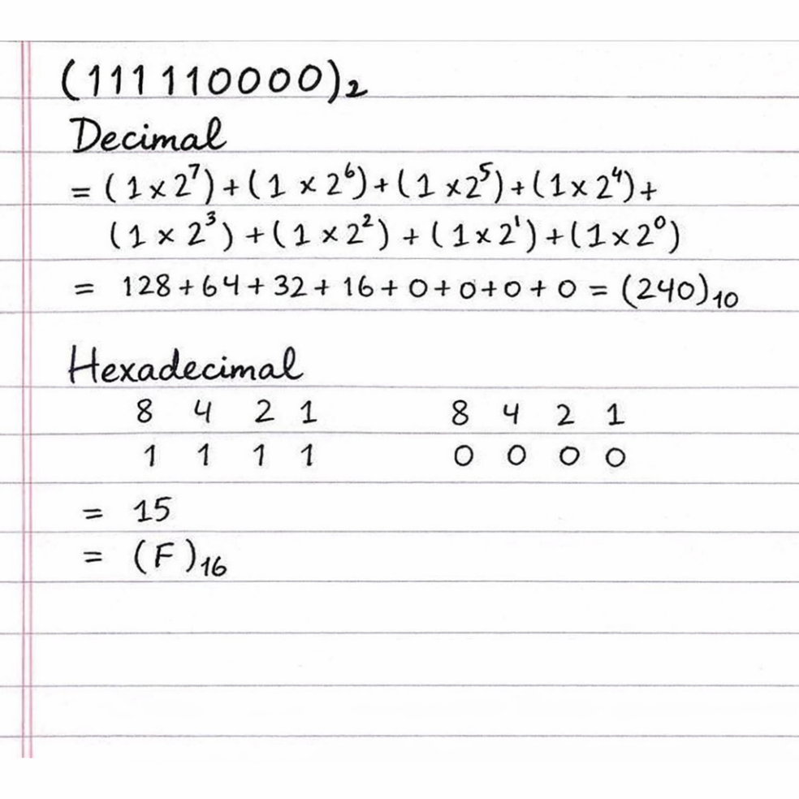

Question no 3:
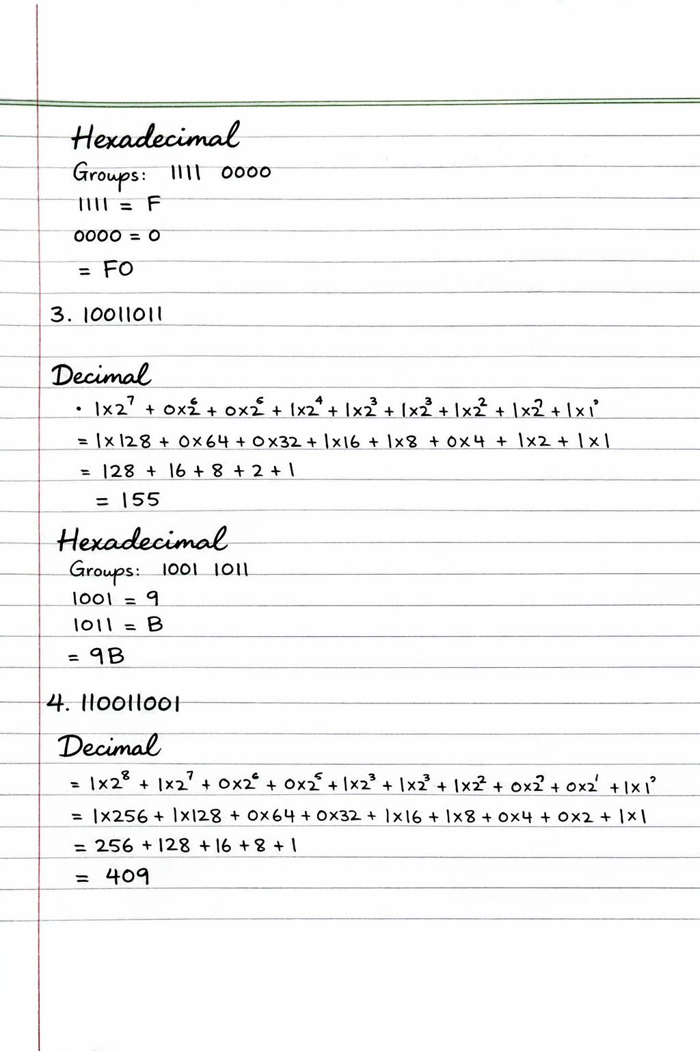

Question no 4
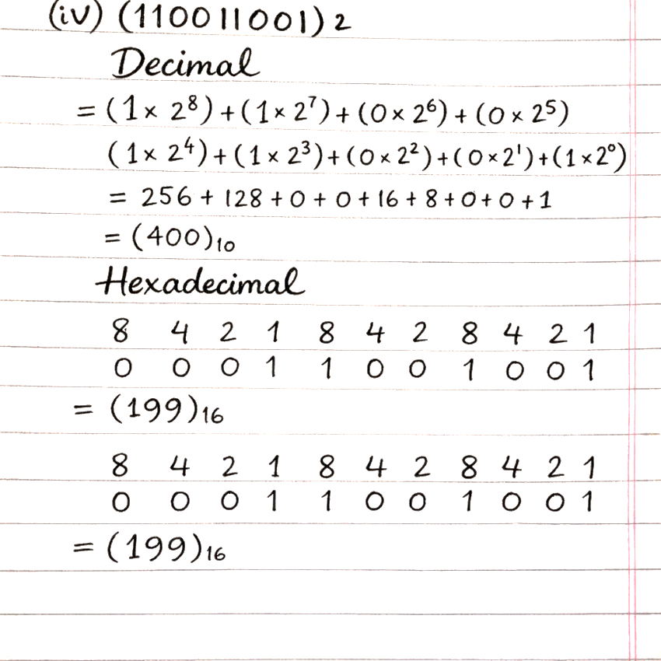
Task 3: Hexa decimal conversion
Question no 1:
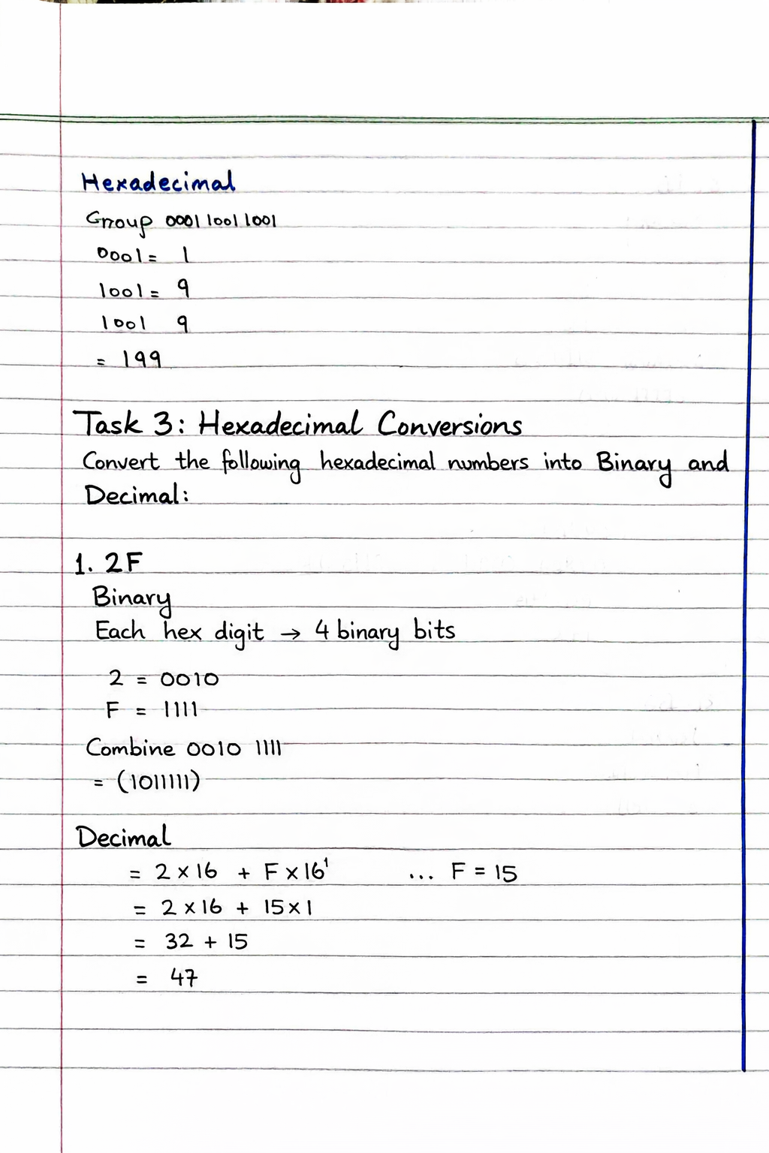
Question no 2:
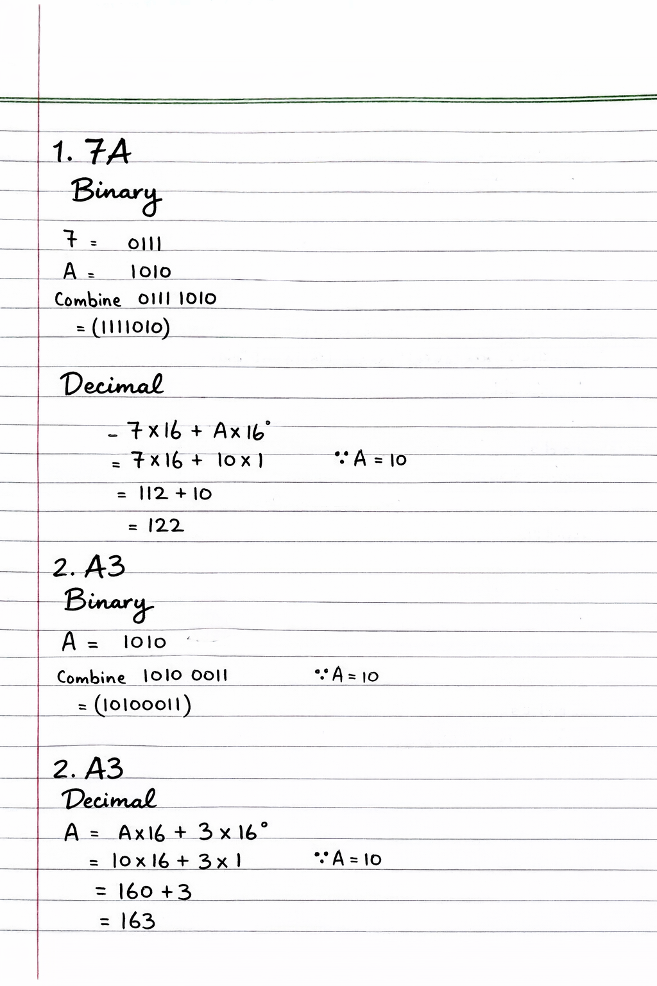

Question no 3:

Question no 4:
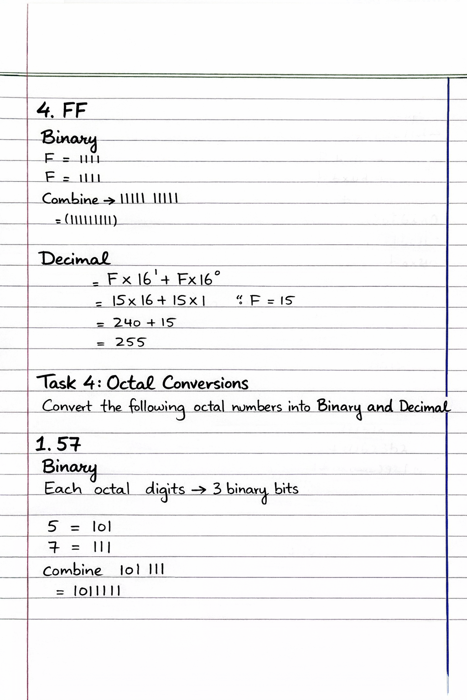

Task 4:
Octal Conversion
Convert the following in octal and binary
Question no 1:
Binary:

Decimal:
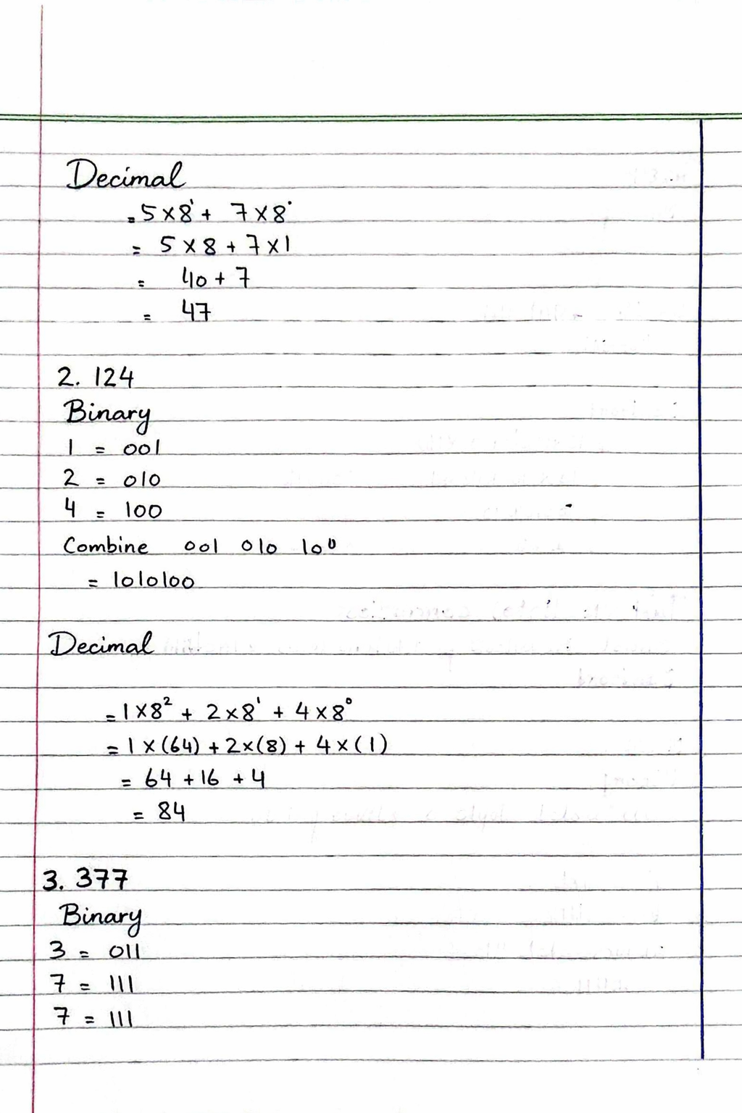
Question no 2:

Question no 3:
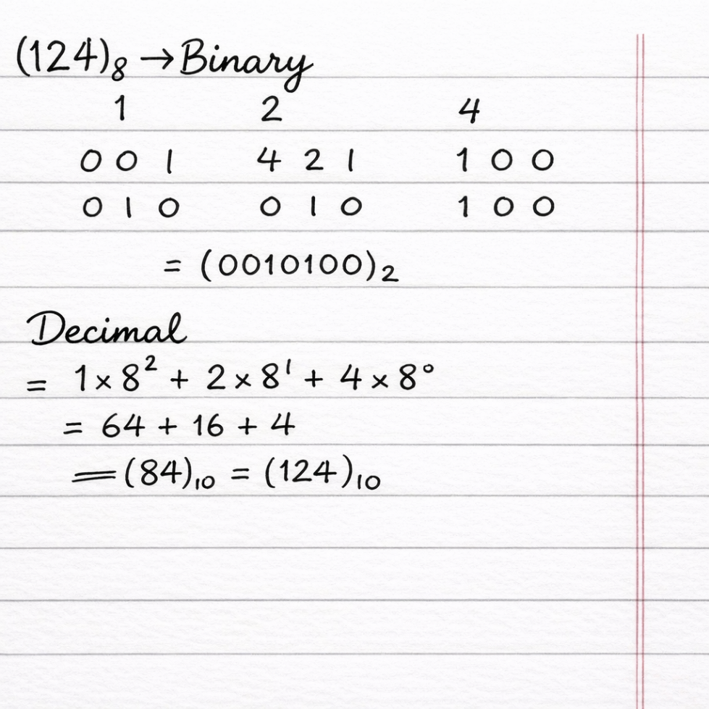

Question no 4:
